==================================================

Running Genetic Algorithm with HistGradientBoosting...

==================================================

==================================================

=== GENETIC ALGORITHM OPTIMIZATION ===

==================================================

[Initialization]

- Population size: 30

- Generations: 20

- Crossover rate: 80%

- Mutation rate: 20%

- Search space: 176 features

- Target: Minimize MSE using HistGradientBoosting

==================================================

=== OPTIMIZATION RESULTS ===

==================================================

▶ Best MSE achieved: 10357.093844

▶ Time elapsed: 522.18 seconds

▶ Features selected: 88/176 (50.0% reduction)

▶ Selected features:

1. District

2. Neighborhood

3. m² (Gross)

4. Number of rooms

5. Floor location

6. Number of floors

7. Heating

8. Number of bathrooms

9. Available for Loan

10. Front East

11. Front North

12. Aluminum joinery

13. Elevator

14. Household appliances

15. Painted

16. Refrigerator

17. Parents' Bathroom

18. Fiber Internet

19. On

20. Intercom System

21. Insulating glass

22. Jacuzzi

23. Plasterboard

24. Cellar

25. Air conditioning

26. Tub

27. Laminate Floor

28. Furniture

29. Kitchen (Built-in)

30. Blinds

31. Ceramic Floor

32. Set Top Cooker

33. Thermosiphon

34. Cloakroom

35. Face Recognition & Fingerprint

36. Washing machine

37. Laundry room

38. Steel door

39. Water heater

40. Elevator.1

41. Security

42. Booster

43. Thermal Insulation

44. Generator

45. Closed Garage

46. Doorman

47. Nursery

48. Car park

49. Sauna

50. Sports Area

51. Water tank

52. Tennis court

53. Satellite

54. Parking Lot

55. Elevator.2

56. Handle / Railing

57. Toilet

58. The mall

59. Pharmacy

60. Amusement center

61. The church

62. The health clinic

63. District Market

64. Gym

65. Primary School-Secondary School

66. Fire Department

67. Town center

68. Highway

69. Eurasia Tunnel

70. Bosphorus Bridges

71. Sea bus

72. E-5

73. Airport

74. Metrobus

75. Minibus

76. Bus stop

77. Coast

78. Cable car

79. Tram

80. Railway station

81. Trolley bus

82. Throat

83. Sea

84. Mezzanine

85. Floor Duplex

86. Rerse Duplex

87. Triplex

88. Ground floor

▶ Convergence progress:

- Initial MSE: 11089.1048

- Final MSE: 10357.0938

- Improvement: 6.6%

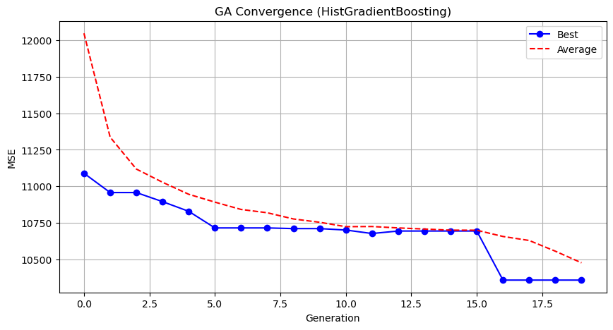

Genetic Algorithm completed successfully with MSE: 10357.0938

==================================================

Running Particle Swarm Optimization with HistGradientBoosting...

==================================================

==================================================

=== PARTICLE SWARM OPTIMIZATION ===

==================================================

[Initialization]

- Swarm size: 30 particles

- Iterations: 20

- Cognitive weight: 0.5

- Social weight: 0.5

- Inertia weight: 0.5

- Search space: 176 features

- Target: Minimize MSE using HistGradientBoosting

==================================================

=== OPTIMIZATION RESULTS ===

==================================================

▶ Best MSE achieved: 10121.209322

▶ Time elapsed: 574.41 seconds

▶ Features selected: 102/176 (42.0% reduction)

▶ Selected features (with weights):

1. District (weight: 0.918)

2. Neighborhood (weight: 0.679)

3. m² (Gross) (weight: 0.536)

4. Number of rooms (weight: 0.624)

5. Building Age (weight: 0.907)

6. Floor location (weight: 0.610)

7. Number of floors (weight: 0.623)

8. Heating (weight: 0.674)

9. Number of bathrooms (weight: 0.797)

10. Balcony (weight: 0.934)

11. Available for Loan (weight: 0.672)

12. From who (weight: 0.631)

13. Swap (weight: 0.976)

14. Front West (weight: 0.943)

15. Front South (weight: 0.811)

16. Wood Joinery (weight: 0.824)

17. Alarm (Thief) (weight: 0.965)

18. American Door (weight: 0.881)

19. American kitchen (weight: 0.784)

20. Built-in on (weight: 0.803)

21. Balcony.1 (weight: 0.772)

22. Household appliances (weight: 0.643)

23. Dishwasher (weight: 0.756)

24. Parents' Bathroom (weight: 0.866)

25. Fiber Internet (weight: 0.939)

26. On (weight: 0.913)

27. Dressing room (weight: 0.791)

28. Closet (weight: 0.552)

29. Insulating glass (weight: 0.613)

30. Jacuzzi (weight: 0.997)

31. Plasterboard (weight: 0.558)

32. Cellar (weight: 0.982)

33. Laminate Floor (weight: 0.621)

34. Furniture (weight: 0.774)

35. Kitchen Natural Gas (weight: 0.910)

36. Blinds (weight: 1.000)

37. Parquet Floor (weight: 1.000)

38. Ceramic Floor (weight: 0.568)

39. Wi-Fi (weight: 0.644)

40. Washing machine (weight: 0.728)

41. Steel door (weight: 0.824)

42. Fireplace (weight: 0.755)

43. Elevator.1 (weight: 1.000)

44. Steam room (weight: 1.000)

45. Security (weight: 0.992)

46. Thermal Insulation (weight: 0.798)

47. Generator (weight: 0.535)

48. Cable TV (weight: 0.776)

49. Doorman (weight: 0.583)

50. Nursery (weight: 1.000)

51. Car park (weight: 0.977)

52. Playground (weight: 0.732)

53. Sauna (weight: 0.988)

54. Siding (weight: 0.636)

55. Water tank (weight: 1.000)

56. Tennis court (weight: 0.767)

57. Fire escape (weight: 0.866)

58. Swimming Pool (Open) (weight: 1.000)

59. Swimming Pool (Indoor) (weight: 0.976)

60. Elevator.2 (weight: 0.644)

61. Bathroom (weight: 0.901)

62. Wide Corridor (weight: 0.946)

63. Entrance / Ramp (weight: 0.813)

64. Room door (weight: 0.535)

65. Park (weight: 0.643)

66. Socket / Electric Switch (weight: 0.682)

67. Handle / Railing (weight: 0.721)

68. The mall (weight: 1.000)

69. Cemevi (weight: 0.957)

70. Next to sea shore (weight: 0.990)

71. Pharmacy (weight: 0.931)

72. Fair (weight: 0.783)

73. Hospital (weight: 0.947)

74. Synagogue (weight: 0.591)

75. Market (weight: 0.589)

76. Primary School-Secondary School (weight: 0.915)

77. Eurasia Tunnel (weight: 0.807)

78. Bosphorus Bridges (weight: 0.967)

79. Sea bus (weight: 0.897)

80. E-5 (weight: 0.792)

81. Marmaray (weight: 0.973)

82. Metro (weight: 0.904)

83. Minibus (weight: 0.940)

84. Bus stop (weight: 0.899)

85. Cable car (weight: 0.976)

86. Tram (weight: 0.735)

87. Railway station (weight: 0.952)

88. Throat (weight: 0.783)

89. Sea (weight: 0.923)

90. Lake (weight: 0.837)

91. Pool (weight: 0.786)

92. Park & ​​Green Area (weight: 0.963)

93. City (weight: 0.930)

94. Garden (weight: 0.993)

95. Top floor (weight: 0.792)

96. Garage / Shop Top (weight: 0.998)

97. Entrance floor (weight: 0.750)

98. Floor Duplex (weight: 0.559)

99. Private Entry (weight: 0.560)

100. Rerse Duplex (weight: 0.557)

101. Triplex (weight: 1.000)

102. Ground floor (weight: 0.590)

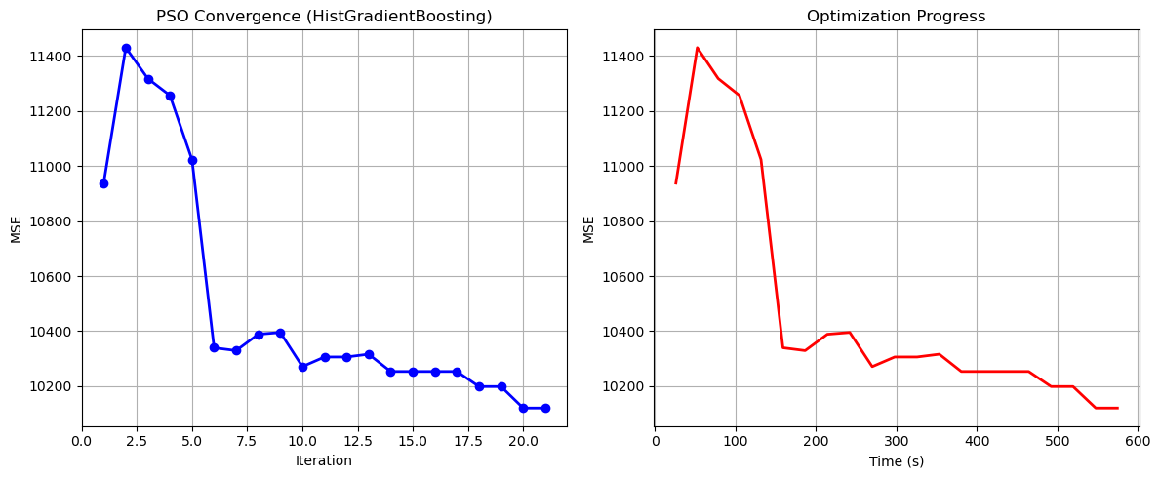

Particle Swarm Optimization completed successfully with MSE: 10121.2093

==================================================

Running Whale Optimization with HistGradientBoosting...

==================================================

==================================================

=== WHALE OPTIMIZATION ALGORITHM ===

==================================================

[Initialization]

- Population: 30 whales

- Max iterations: 20

- Spiral coefficient (b): 1.0

- Search space: 176 features

- Target: Minimize MSE using HistGradientBoosting

[Optimization Progress]

Iter 20/20 | Best MSE: 10204.926585

==================================================

=== OPTIMIZATION RESULTS ===

==================================================

▶ Best MSE achieved: 10204.926585

▶ Time elapsed: 641.14 seconds

▶ Features selected: 163/176 (7.4% reduction)

▶ Selected features:

1. District

2. Neighborhood

3. m² (Gross)

4. m² (Net)

5. Number of rooms

6. Building Age

7. Floor location

8. Number of floors

9. Heating

10. Number of bathrooms

11. Balcony

12. Furnished

13. Using status

14. Available for Loan

15. From who

16. Swap

17. Front West

18. Front East

19. Front South

20. ADSL

21. Wood Joinery

22. Smart House

23. Alarm (Thief)

24. Alaturka Toilet

25. American Door

26. American kitchen

27. Built-in on

28. Elevator

29. Balcony.1

30. Barbecue

31. Household appliances

32. Painted

33. Dishwasher

34. Refrigerator

35. Wall paper

36. Shower

37. Parents' Bathroom

38. On

39. Dressing room

40. Closet

41. Video intercom

42. Hilton Bathroom

43. Intercom System

44. Insulating glass

45. Jacuzzi

46. Plasterboard

47. Cellar

48. Air conditioning

49. Tub

50. Laminate Floor

51. Marley

52. Furniture

53. Kitchen (Built-in)

54. Kitchen (Laminate)

55. Kitchen Natural Gas

56. PVC Joinery

57. Blinds

58. Parquet Floor

59. Ceramic Floor

60. Set Top Cooker

61. Spot Lighting

62. Terrace

63. Thermosiphon

64. Wi-Fi

65. Face Recognition & Fingerprint

66. Washing Machine

67. Washing machine

68. Steel door

69. Water heater

70. Fireplace

71. Elevator.1

72. Steam room

73. Security

74. Bath

75. Booster

76. Thermal Insulation

77. Generator

78. Cable TV

79. Closed Garage

80. Doorman

81. Nursery

82. With Private Pool

83. Car park

84. Playground

85. Sauna

86. Sound insulation

87. Siding

88. Sports Area

89. Water tank

90. Tennis court

91. Satellite

92. Fire escape

93. Swimming Pool (Open)

94. Swimming Pool (Indoor)

95. Parking Lot

96. Elevator.2

97. Bathroom

98. Wide Corridor

99. Entrance / Ramp

100. Stairs

101. Kitchen

102. Room door

103. Park

104. Socket / Electric Switch

105. Handle / Railing

106. Toilet

107. Swimming pool

108. The mall

109. municipality

110. Mosque

111. Cemevi

112. Next to sea shore

113. Pharmacy

114. Amusement center

115. Fair

116. Hospital

117. Synagogue

118. High school

119. Market

120. Park.1

121. The health clinic

122. District Market

123. Gym

124. Unirsity

125. Primary School-Secondary School

126. Fire Department

127. Town center

128. Eurasia Tunnel

129. Bosphorus Bridges

130. Street

131. Sea bus

132. Filled

133. E-5

134. Airport

135. Marmaray

136. Metro

137. Metrobus

138. Minibus

139. Bus stop

140. Coast

141. TEM

142. Cable car

143. Tram

144. Railway station

145. Trolley bus

146. Scaffolding

147. Throat

148. Sea

149. Nature

150. Lake

151. Pool

152. City

153. Mezzanine

154. Mezzanine Duplex

155. Garden Duplex

156. Garden

157. Top floor

158. Garage / Shop Top

159. Entrance floor

160. Floor Duplex

161. Private Entry

162. Rerse Duplex

163. Triplex

▶ Convergence progress:

- Initial MSE: 11031.3232

- Final MSE: 10374.6744

- Improvement: 6.0%

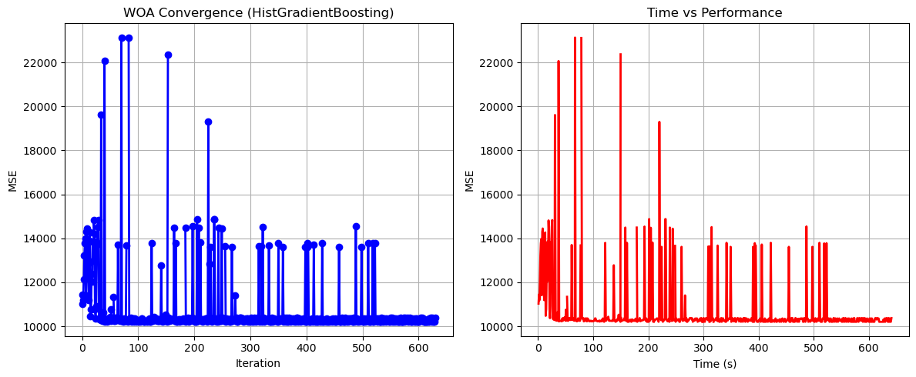

Whale Optimization completed successfully with MSE: 10204.9266

==================================================

Running Squid Game Optimizer with HistGradientBoosting...

==================================================

==================================================

=== SQUID GAME OPTIMIZER (SGO) ===

==================================================

[Initialization]

- Players: 30 (15 offensive, 15 defensive)

- Max games: 20

- Search space: 176 features

- Target: Minimize MSE using HistGradientBoosting

==================================================

=== OPTIMIZATION RESULTS ===

==================================================

▶ Best MSE achieved: 10094.138355

▶ Time elapsed: 539.38 seconds

▶ Features selected: 71/176 (59.7% reduction)

▶ Selected features:

1. District

2. Neighborhood

3. m² (Gross)

4. Number of rooms

5. Building Age

6. Floor location

7. Number of floors

8. Heating

9. Balcony

10. Available for Loan

11. Front East

12. Front North

13. Wood Joinery

14. Alarm (Thief)

15. Built-in on

16. Painted

17. Dishwasher

18. Shower

19. Parents' Bathroom

20. Closet

21. Furniture

22. Kitchen (Built-in)

23. Kitchen (Laminate)

24. Kitchen Natural Gas

25. Blinds

26. Parquet Floor

27. Spot Lighting

28. Thermosiphon

29. Wi-Fi

30. Face Recognition & Fingerprint

31. Washing machine

32. Steel door

33. Water heater

34. Booster

35. Thermal Insulation

36. Closed Garage

37. Car park

38. Playground

39. Siding

40. Tennis court

41. Parking Lot

42. Elevator.2

43. Room door

44. Socket / Electric Switch

45. Handle / Railing

46. Toilet

47. The mall

48. Mosque

49. Pharmacy

50. Amusement center

51. Fair

52. The church

53. The health clinic

54. District Market

55. Gym

56. Primary School-Secondary School

57. Fire Department

58. Eurasia Tunnel

59. Bosphorus Bridges

60. Filled

61. Metrobus

62. Bus stop

63. TEM

64. Cable car

65. Trolley bus

66. Sea

67. City

68. Mezzanine

69. Garden

70. Entrance floor

71. Floor Duplex

▶ Convergence progress:

- Initial MSE: 10561.3827

- Final MSE: 10094.1384

- Improvement: 4.4%

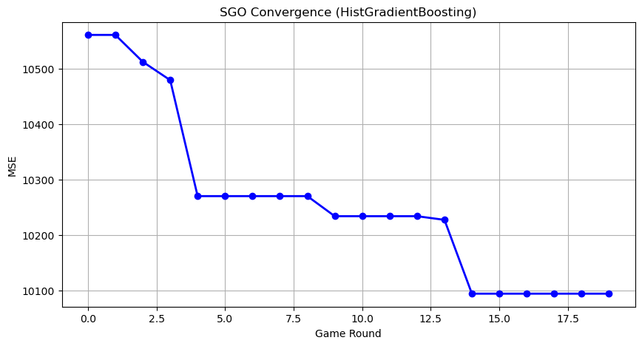

Squid Game Optimizer completed successfully with MSE: 10094.1384

==================================================

Running PSH-Hyptrite with HistGradientBoosting...

==================================================

==================================================

=== PSH-HYPTRITE OPTIMIZATION ===

==================================================

[Initialization]

- Search points: 30

- Max iterations: 20

- Initial radius: 0.5 (adaptive)

- Hypersphere samples: 3 per point

- Search space: 176 features

- Target: Minimize MSE using HistGradientBoosting

[Optimization Progress]

Iter 20/20 | Best MSE: 10092.137227 | Radius: 0.0250

==================================================

=== OPTIMIZATION RESULTS ===

==================================================

▶ Best MSE achieved: 10092.137227

▶ Time elapsed: 1635.59 seconds

▶ Features selected: 93/176 (47.2% reduction)

▶ Selected features (with weights):

1. District (weight: 0.990)

2. Neighborhood (weight: 0.642)

3. m² (Gross) (weight: 0.608)

4. m² (Net) (weight: 0.709)

5. Number of rooms (weight: 0.739)

6. Building Age (weight: 0.970)

7. Floor location (weight: 0.557)

8. Number of floors (weight: 0.547)

9. Heating (weight: 0.790)

10. Number of bathrooms (weight: 0.956)

11. Furnished (weight: 0.810)

12. Using status (weight: 0.638)

13. Available for Loan (weight: 0.527)

14. From who (weight: 0.980)

15. Front West (weight: 0.883)

16. Front South (weight: 0.666)

17. Smart House (weight: 0.814)

18. Alarm (Fire) (weight: 0.757)

19. Aluminum joinery (weight: 0.678)

20. Household appliances (weight: 0.858)

21. Painted (weight: 0.998)

22. Dishwasher (weight: 0.912)

23. Refrigerator (weight: 0.914)

24. Shower (weight: 0.689)

25. Parents' Bathroom (weight: 0.952)

26. Dressing room (weight: 0.563)

27. Plasterboard (weight: 0.762)

28. Air conditioning (weight: 0.711)

29. Tub (weight: 0.787)

30. Laminate Floor (weight: 0.847)

31. Kitchen (Built-in) (weight: 0.735)

32. Kitchen Natural Gas (weight: 0.846)

33. PVC Joinery (weight: 0.822)

34. Blinds (weight: 0.975)

35. Set Top Cooker (weight: 0.890)

36. Thermosiphon (weight: 0.946)

37. Face Recognition & Fingerprint (weight: 0.944)

38. Washing machine (weight: 0.903)

39. Laundry room (weight: 0.579)

40. Steel door (weight: 0.568)

41. Fireplace (weight: 0.571)

42. Security (weight: 0.726)

43. Booster (weight: 0.551)

44. Thermal Insulation (weight: 0.515)

45. Generator (weight: 0.722)

46. Cable TV (weight: 0.509)

47. Closed Garage (weight: 0.663)

48. Doorman (weight: 0.548)

49. With Private Pool (weight: 0.728)

50. Playground (weight: 0.828)

51. Sauna (weight: 0.575)

52. Sound insulation (weight: 0.750)

53. Siding (weight: 0.820)

54. Sports Area (weight: 0.707)

55. Water tank (weight: 0.669)

56. Tennis court (weight: 0.787)

57. Swimming Pool (Indoor) (weight: 0.582)

58. Parking Lot (weight: 0.798)

59. Socket / Electric Switch (weight: 0.544)

60. Toilet (weight: 0.709)

61. Swimming pool (weight: 0.824)

62. The mall (weight: 0.569)

63. Mosque (weight: 0.924)

64. Pharmacy (weight: 0.611)

65. Amusement center (weight: 0.723)

66. Hospital (weight: 0.508)

67. High school (weight: 0.645)

68. Market (weight: 0.697)

69. Park.1 (weight: 0.748)

70. The health clinic (weight: 0.570)

71. District Market (weight: 0.811)

72. Primary School-Secondary School (weight: 0.909)

73. Fire Department (weight: 0.629)

74. Eurasia Tunnel (weight: 0.653)

75. Bosphorus Bridges (weight: 0.945)

76. Marmaray (weight: 0.615)

77. Minibus (weight: 0.987)

78. Bus stop (weight: 0.553)

79. TEM (weight: 0.919)

80. Tram (weight: 1.000)

81. Railway station (weight: 0.587)

82. Trolley bus (weight: 0.859)

83. Scaffolding (weight: 0.925)

84. Throat (weight: 0.538)

85. Nature (weight: 0.839)

86. Lake (weight: 0.962)

87. Park & ​​Green Area (weight: 0.901)

88. Mezzanine (weight: 0.814)

89. Garden Floor (weight: 0.567)

90. Garden (weight: 0.673)

91. Top floor (weight: 0.885)

92. Entrance floor (weight: 0.923)

93. Private Entry (weight: 0.508)

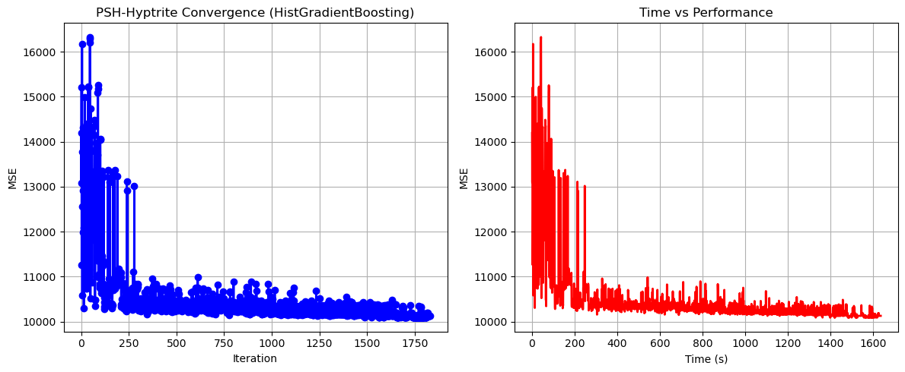

PSH-Hyptrite completed successfully with MSE: 10092.1372

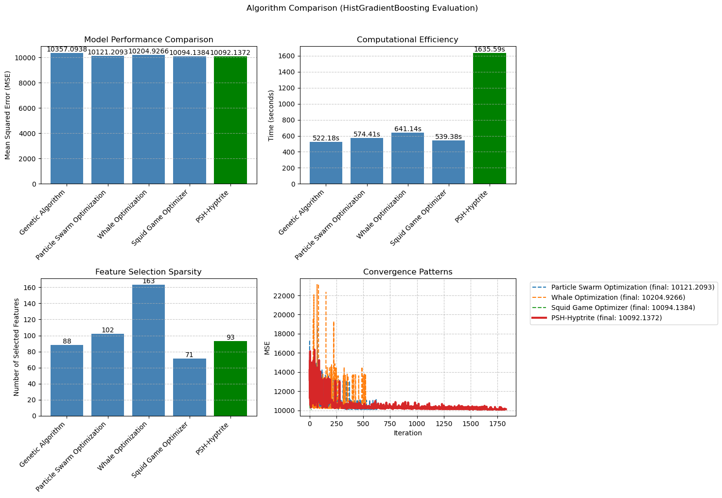

============================================================

=== FINAL FEATURE SELECTION RESULTS USING HistGradientBoosting ===

============================================================

🏆 BEST ALGORITHM: PSH-HYPTRITE

• MSE: 10092.137227

• Time: 1635.59 seconds

• Features: 93/176 (47.2% reduction)

📊 COMPARISON TABLE:

Algorithm MSE Time (s) Features

---------------------------------------------------------------------------

PSH-Hyptrite 10092.137227 1635.59 93

Squid Game Optimizer 10094.138355 539.38 71

Particle Swarm Optimization 10121.209322 574.41 102

Whale Optimization 10204.926585 641.14 163

Genetic Algorithm 10357.093844 522.18 88

🔍 SELECTED FEATURES:

1. District

2. Neighborhood

3. m² (Gross)

4. m² (Net)

5. Number of rooms

6. Building Age

7. Floor location

8. Number of floors

9. Heating

10. Number of bathrooms

11. Furnished

12. Using status

13. Available for Loan

14. From who

15. Front West

16. Front South

17. Smart House

18. Alarm (Fire)

19. Aluminum joinery

20. Household appliances

21. Painted

22. Dishwasher

23. Refrigerator

24. Shower

25. Parents' Bathroom

26. Dressing room

27. Plasterboard

28. Air conditioning

29. Tub

30. Laminate Floor

31. Kitchen (Built-in)

32. Kitchen Natural Gas

33. PVC Joinery

34. Blinds

35. Set Top Cooker

36. Thermosiphon

37. Face Recognition & Fingerprint

38. Washing machine

39. Laundry room

40. Steel door

41. Fireplace

42. Security

43. Booster

44. Thermal Insulation

45. Generator

46. Cable TV

47. Closed Garage

48. Doorman

49. With Private Pool

50. Playground

51. Sauna

52. Sound insulation

53. Siding

54. Sports Area

55. Water tank

56. Tennis court

57. Swimming Pool (Indoor)

58. Parking Lot

59. Socket / Electric Switch

60. Toilet

61. Swimming pool

62. The mall

63. Mosque

64. Pharmacy

65. Amusement center

66. Hospital

67. High school

68. Market

69. Park.1

70. The health clinic

71. District Market

72. Primary School-Secondary School

73. Fire Department

74. Eurasia Tunnel

75. Bosphorus Bridges

76. Marmaray

77. Minibus

78. Bus stop

79. TEM

80. Tram

81. Railway station

82. Trolley bus

83. Scaffolding

84. Throat

85. Nature

86. Lake

87. Park & ​​Green Area

88. Mezzanine

89. Garden Floor

90. Garden

91. Top floor

92. Entrance floor

93. Private Entry

💡 Tip: Consider feature importance from HistGradientBoosting for further analysis